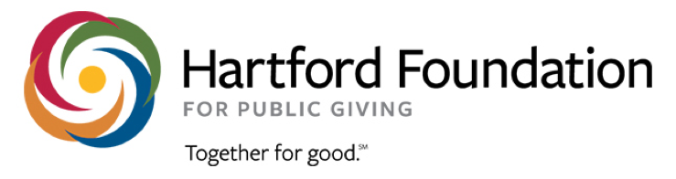 | Hartford Community Fund  Advisory Committee Application Form
Thank you for your interest in the Hartford Community Fund Advisory Committee!

Please complete and submit this form to the Hartford Community Fund Selection Committee at hartfordgreatertogether@gmail.com on or before July 15, 2020.

If you know of someone who might be interested in serving on the Advisory Committee, please share this form with them, or send an email nominating them to hartfordgreatertogether@gmail.com by July 1 and we will contact them.

Full Name:
Click or tap here to enter text.

Phone Number:  Click or tap here to enter text. | Organizational affiliation (if any):  Click or tap here to enter text.
Email Address:  Click or tap here to enter text. | Address:  Click or tap here to enter text.
Why are you interested in participating in the Advisory Committee for Hartford’s Greater Together Community Fund?
Click or tap here to enter text.

What do you hope to contribute to the Advisory Committee?
Click or tap here to enter text.

What do you see as the greatest needs in your community?
Click or tap here to enter text.

We aim to create a committee that reflects the diverse perspectives in Hartford. What would you like to share about your identity? Examples of identity include race, ethnicity, gender, socioeconomic status, sexual orientation, religion, age, country of origin, educational background, work experience.
Click or tap here to enter text.

What would you hope to get out of serving on the Advisory Committee?
Click or tap here to enter text.

