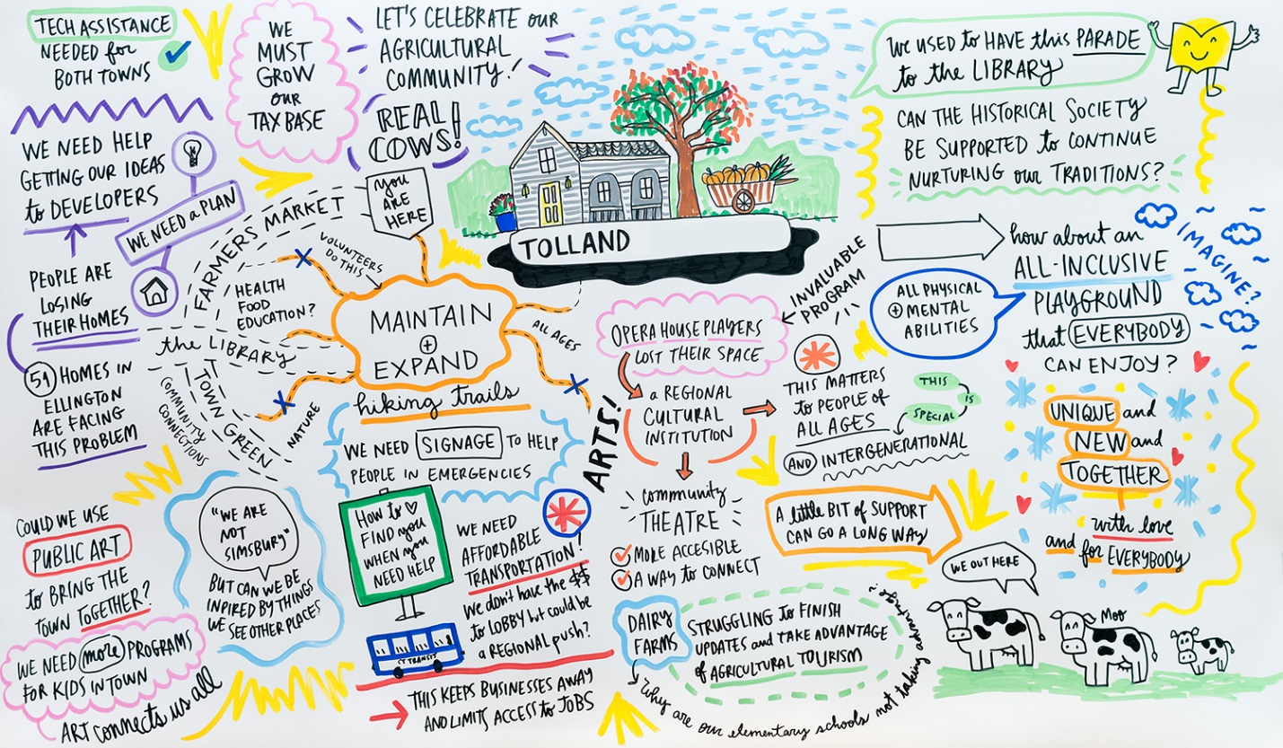

New Tolland Community Fund
Seeks Student Applicants to the Advisory Committee

The Town of Tolland has recently been presented with a dynamic civic opportunity, one that incorporates grant funds for programs and citizen participation. In 2019, the Hartford Foundation for Public Giving established $100,000 community funds for each of the 29 towns in the Foundation’s region, which includes Tolland. The purpose of the community funds is to support residents in taking ownership around the needs in their towns, encourage broad and inclusive civic engagement and anchor the Hartford Foundation in each town.

Town residents will play a lead role in deciding how Tolland’s community funds will be used. An advisory committee of Tolland residents has recently formed. This advisory committee will identify community needs and design a grantmaking process aimed to ensure that the community funds can have the greatest impact for the benefit of town residents.

The Advisory Committee seeks to add student members to the committee to serve a minimum of one year. To apply to serve on the Tolland Community Fund Advisory Committee, please complete the form at www.hfpg.org/tollandcf and email to hfpg4tolland@gmail.com. The application deadline is July 1.

Tolland Greater Together Community Fund
Advisory Committee Application Form
Full Name:

Phone Number: | What school do you attend:
Email Address: | Address:
Why are you interested in participating in the Advisory Committee for Tolland’s Greater Together Community Fund?

What perspectives, talents or skill sets would you bring as an advisory committee member?

Have you been part of any school group, clubs or other activities?

If you are under 18 years of age, you will need permission from a parent or legal guardian to apply.
I ____________________________ give permission for ___________________________ to apply to be a member of the Tolland Community Fund Advisory Committee, and if accepted, to participate in meetings / activities of the same. I understand the Community Fund may wish to make known the success of this effort, and I authorize my child to appear in photographs or videos for this purpose.

Parent / Guardian Signature: _______________________________ Date: _______________

