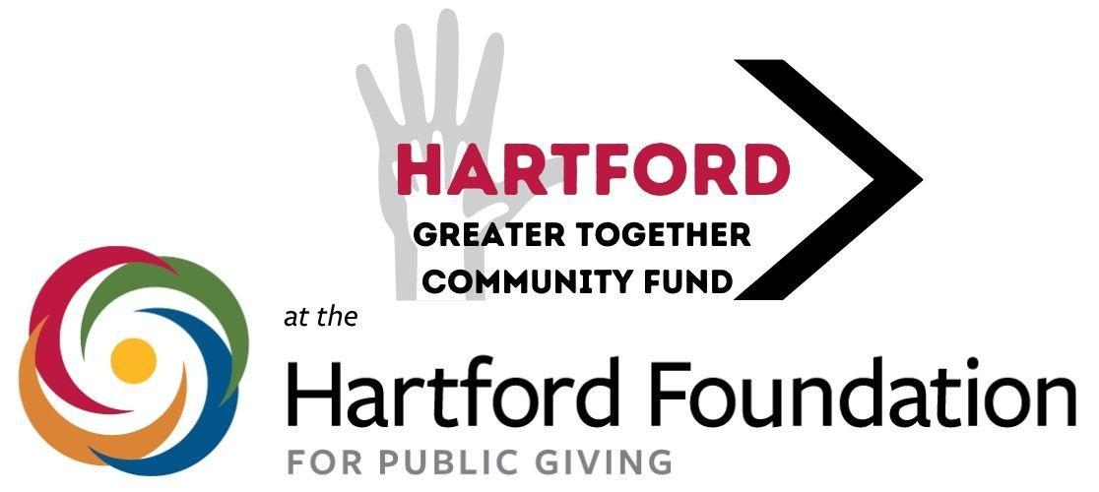

**Media Contact:** David Barrett - Committee Member | [hartford@hfpgcommunityfunds.org](mailto:hartford@hfpgcommunityfunds.org)

Chris Senecal, Hartford Foundation for Public Giving, [csenecal@hfpg.org](mailto:csenecal@hfpg.org)

**Hartford’s Greater Together Community Fund Is Seeking a New Round of Proposals for Projects to Benefit Hartford Residents**

*Hartford, CT -* The [Hartford Greater Together Community Fund at the Hartford Foundation for Public Giving](https://www.hfpg.org/donors/ways-to-give/community-funds/hartford) is now seeking funding proposals from nonprofit organizations working to serve Hartford residents. Applications will be accepted starting August 1.

The Fund, established by the Hartford Foundation in 2019, is directed by a committee of Hartford residents from various backgrounds and supports residents in taking ownership around the needs of Hartford through grantmaking.

The Fund aims to support local nonprofits that are serving Hartford residents to address critical needs in housing security, food security, childcare, health care, wellness, job readiness, literacy, the arts and other critical issues – understanding that these nonprofits are the backbone of grassroots efforts to better Hartford.

"This will be the fifth year that the committee will award grants, and we are very pleased to have been able to support the region’s non-profits working to better the lives of Hartford residents. So far, we have awarded 44 grants totaling $120,730,” says Lara Langer, Chair of the Hartford Greater Together Community Fund's Committee. "Our committee members have visited several of the grantees this year and observed firsthand the amazing work they do, from providing clothing and food to those in need to enhancing neo-natal care for expectant moms to literacy education, and arts enrichment opportunities for children and adults. We are proud to support these local efforts. We remain grateful to the Hartford Foundation for Public Giving, which began this initiative to empower the citizens of their towns to take ownership of the needs of their communities."

This year, the committee will award grants of $500 to $5,000 to eligible 501(c)(3) organizations for programmatic support. Projects must primarily serve Hartford residents. New this year, the committee has increased the permissible annual operating budget; now nonprofits with annual operating budgets of $1.5 million or less may apply.

To enhance strategic impact, the committee is encouraging collaborative projects among eligible organizations.

Applications are available at [HFPG.org/HartfordCF](http://hfpg.org/HartfordCF)

Applicants may apply online or print out the application form and submit it via PDF to [hartford@hfpgcommunityfunds.org](mailto:hartford@hfpgcommunityfunds.org). The deadline for applying is 11:59 pm on September 12, 2025.

Organizations that received grants in 2024 must have submitted their final reports to be eligible for this new cycle of grants. Organizations that have received grants in three consecutive years are not eligible this year.

Online information sessions for applicants are scheduled for July 29 and September 2 at 6 p.m. They will be held virtually via Zoom. To register, go to [HFPG.org/HartfordCF](http://hfpg.org/HartfordCF) or contact the committee at [hartford@hfpgcommunityfunds.org](mailto:hartford@hfpgcommunityfunds.org) for the registration form.

For questions about the fund or application process, please email [hartford@hfpgcommunityfunds.org](mailto:hartford@hfpgcommunityfunds.org).

In 2019, the Hartford Foundation established the Greater Together Community Funds in each of the 29 towns it serves, providing an initial investment of $100,000. In 2021, the Foundation awarded an additional $50,000 to each of the community funds. In January, as part of the Hartford Foundation for Public Giving’s Centennial year in 2025 and the Fifth anniversary of the Greater Together Community Fund program, the Foundation unveiled a new $100,000 investment in each of its 29 town-specific Community Funds. This includes $50,000 immediately available for grantmaking and $50,000 allocated to endowment.

*The Hartford Foundation for Public Giving is the community foundation for Hartford and 28 surrounding communities. Made possible by the gifts of generous individuals, families and organizations, the Foundation has awarded grants of more than $1 billion since its founding in 1925. For more information about the Hartford Foundation for Public Giving, visit* [*www.hfpg.org*](http://www.hfpg.org) *or call 860-548-1888.*

##