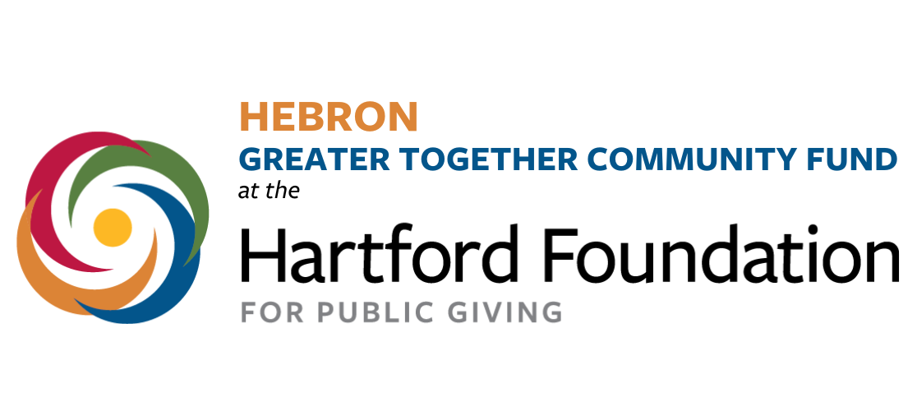

Hebron Greater Together Community Fund
Advisory Committee Membership Application

October 15, 2023 Application Deadline

Eligibility

Applicants applying to serve on the Hebron Greater Together Advisory Committee must be a Hebron resident and not a town elected official.

Mission of the Advisory Committee

The Committee is charged with managing the design and implementation of a grant program that funds projects that improve the quality of community life in Hebron. Meetings are held monthly in person.

The Hartford Foundation for Public Giving has provided the funds for the grants awarded, which total $25,000 in 2022 and $25,000 in 2023. The next round of grants will have $25,000 available for projects in 2024.

The Hartford Foundation created the Greater Together Community Fund program in Hebron and 28 other towns in the region for the purpose of taking ownership around the needs of their town.

Application Requirements

- Provide Your contact information: Name, Address, Phone, Email.

- Identify your career interests.

- What are your volunteer affiliations with non-profit organizations (if any).

- Why are you interested in serving on the Hebron Community Fund Advisory Committee.

- Please share any other special interests or goals that you’d like to mention.

- Submit your application to HebronCommunityFund@gmail.com

Note
All qualified applicants will be contacted for a phone or in person interview.

