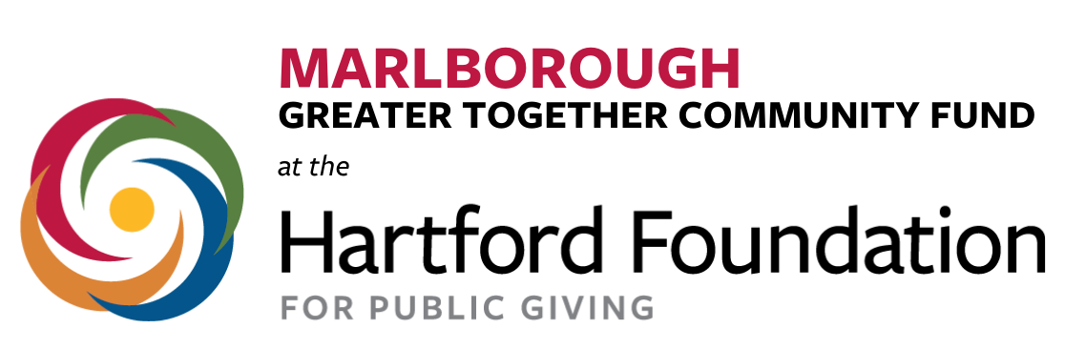

Advisory Committee Membership Application
Full Name:

Phone Number: | Organizational affiliation (if any):
Email Address: | Address:
Age: |  | How many years have you lived in Marlborough
What do you like most about living in Marlborough?

Why are you interested in participating in the Advisory Committee for Marlborough’s Greater Together Community Fund?

What talents or skill sets would you bring as an advisory committee member?

Have you been involved in town or school activities? Please list any groups, organizations or clubs you have been involved with and describe your role.

Is there anything else that you would like to share with us?

PLEASE NOTE:
To submit an application for the Marlborough Community Fund Advisory Committee, please email to communityfund.marlborough@gmail.com.
If applicant is between the ages of 14 – 17 parent or legal guardian permission is required to be considered. Please download the parent consent form at www.hfpg.org/marlboroughcf , complete and email to: communityfund.marlborough@gmail.com.
The deadline for application is June 15, 2022.
If you have any questions, please email the committee at communityfund.marlborough@gmail.com

