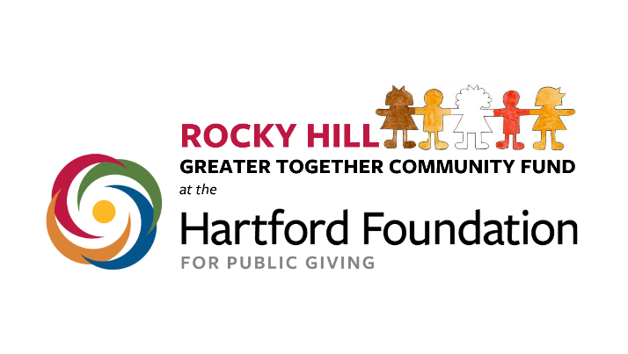

OPEN CALL FOR LETTERS OF INTEREST to Fund PROJECTS BENEFITING THE ROCKY HILL, CT COMMUNITY

Deadline: June 19, 2022

The Rocky Hill Advisory Committee - Greater Together Community Fund is pleased to announce an open call for Letters of Interest for projects directly benefiting the Rocky Hill community for 2022.

About the Rocky Hill Greater Together Community Fund
In 2019, the Hartford Foundation for Public Giving established $100,000 community funds for each of the 29 towns in the Foundation’s region, which includes the town of Rocky Hill. The purpose of the community funds is to support residents in taking ownership around the needs in their towns, encourage broad and inclusive civic engagement and anchor the Hartford Foundation in each town. In 2021, the Rocky Hill Advisory Committee was created to manage the selection process.

About the Hartford Foundation for Public Giving
The Hartford Foundation for Public Giving is the community foundation for Hartford and 28 surrounding communities. Made possible by the gifts of generous individuals, families and organizations, the Foundation has awarded grants of more than $894 million since its founding in 1925. For more information about the Hartford Foundation for Public Giving, visit https://www.hfpg.org or call 860-548-1888.

Purpose of the Call
Through this call, we are inviting Letters of Interest (LOI) for funding available to programs that will improve or enhance the quality of life of Rocky Hill or otherwise contribute to solving a direct need of the Rocky Hill community. Funding may include efforts to improve access to current programs (especially for underserved populations); or innovative new initiatives; or enhancements of current programs. Funding may be used for solving basic human needs (food or shelter), health, human services, disability or mental health services, senior services, education, and recreation/land conservation. The geographic area served is restricted to Rocky Hill, CT. Partnerships or collaborative efforts are encouraged.

Eligibility and Prerequisites
- Any nonprofit registered as a 501(c)(3) organization that serves the residents of Rocky Hill is eligible to submit.
  - Groups of town residents may prepare an application in partnership with a registered nonprofit that has agreed to serve as the fiscal agent for the proposed project. You can also approach the Town of Rocky Hill to ask if they would be willing to serve as a fiscal agent.
  - Nonprofits do not need to be headquartered or based in Rocky Hill.
  - Individuals, private foundations, and for-profit businesses are not eligible to apply.
  - The Rocky Hill Greater Together Community Fund cannot be used to fund programs of sectarian or religious purpose.

Letters of Interest must provide the opportunity for Rocky Hill residents to benefit without discrimination based on race, religion, or any other protected class. The proposed project does not necessarily need to benefit every town resident if the letter can demonstrate why it addresses the need for a portion of the town’s population and does not discriminate among residents who share this need. Letters should briefly describe the project, the population to be impacted, the benefit(s) of the project, any partner organizations, the total budget for the project and the amount requested. Letters should be no more than 2 pages in length.

Potential Funding for each Grant
Funding for each grant will be based on the scope and focus of proposals. The minimum request for any proposal is $250 and the maximum request shall not exceed $25,000. However, additional funding for proposals can be sought from other sources for larger proposals. During this first season of grant applications, up to $25,000 in grants will be funded.

Review and Selection Process
Letters of Interest will be reviewed on a competitive basis by the Rocky Hill Advisory Committee and will be evaluated according to the merit and relevance to the call.

Those Letters of Interest accepted will be notified via email and invited to participate in the next round by submitting a full proposal. This proposal will be a longer document that describes more completely your project, your budget, your goals and how you will measure them.

All grant awards are made at the sole discretion of the Rocky Hill Advisory Committee and upon approval by the Hartford Foundation for Public Giving.

How to submit Letters of Interest?
The deadline for submission of Letters of Interest is June 19, 2022.
Email completed Letters of Interest to RockyHillCommunityFund@gmail.com in a Word Document or PDF format.

Questions about the Call for Letters of Interest may be directed to Ron Cox or Amy Forcier at RockyHillCommunityFund@gmail.com

