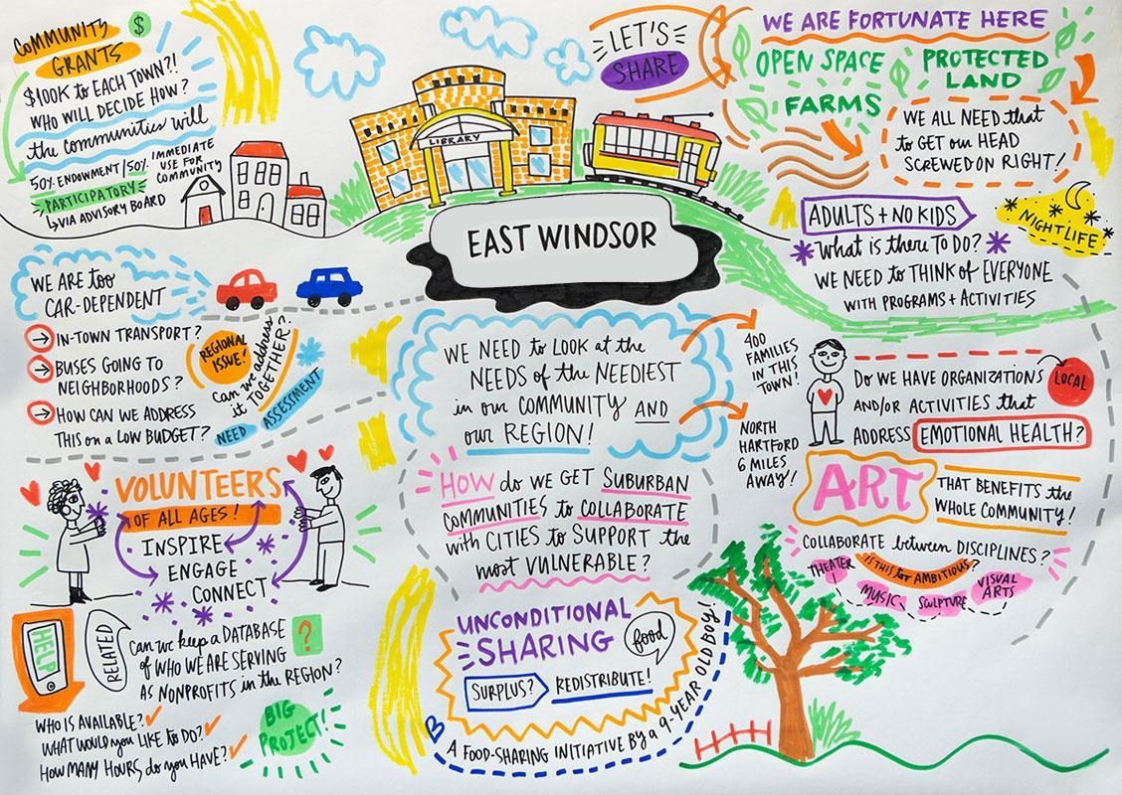

East Windsor Advisory Committee
Greater Together Community Fund
Seeking Applicants

The Town of East Windsor has a dynamic civic opportunity, one that incorporates grant funds for programs and citizen participation. In 2019, the Hartford Foundation for Public Giving established $100,000 community funds for each of the 29 towns in the Foundation’s region, including East Windsor. The purpose of the community funds is to support residents in taking ownership around the needs in their towns and encourage broad and inclusive civic engagement.

An advisory committee of East Windsor residents plays a lead role in deciding how East Windsor’s funds will be used. This advisory committee will identify community needs and design a grantmaking process aimed to ensure that the community funds can have the greatest impact for the benefit of town residents. Please consider joining this exciting committee that will help East Windsor.

The Advisory Committee is seeking members that will help us maintain a diverse, inclusive membership reflective of East Windsor’s unique demographics. All East Windsor residents are eligible to apply including students or young adults ages 14+.

To apply, please complete the form at www.hfpg.org/eastwindsorcf and email to ewcommunityfund@gmail.com or mail to EW Community Fund Advisory Committee, c/o First Selectman’s Office, 10 Rye Street, Broad Brook, CT 06016.

East Windsor Advisory Committee
Greater Together Community Funds
Membership Application Form
Full Name: |  | Phone Number:
Email Address: | Address:
Occupation or if in school what school and grade do you attend:
Why are you interested in becoming a member of the Advisory Committee and what do you hope to bring to the Committee?

How do you describe yourself? You choose the level of disclosure about yourself to share with the Committee (i.e. occupation/interests, introvert/extrovert, skills that would come in handy for being an Advisory member, etc.)

Please list any organizations/committees/club you have been a member of.

Please provide 2 references:

Name: ______________________________ Phone # ______________________

Name: ______________________________ Phone # ______________________

I understand the Community Fund may wish to make known the success of this effort, and I authorize my appearance in photographs or videos for this purpose.

Signature: _______________________________ Date: ________________________

If you are under 18 years of age, you will need permission from a parent or legal guardian to apply.

I, _____________________, give permission for ____________________ to apply to be part of the East Windsor Community Fund Advisory Committee, and if accepted, to participate in meetings/activities of the same and authorize my child to appear in photographs or videos for this purpose.

Parent/Guardian Signature: _____________________________ Date: ______________________

