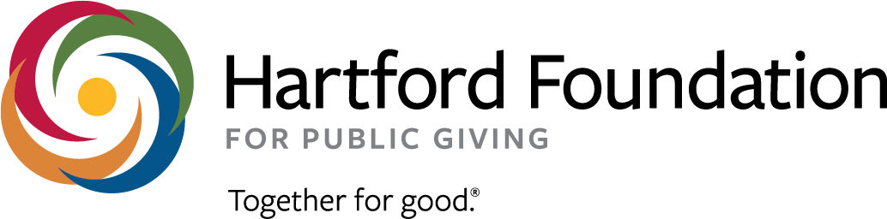
Simsbury Greater Together Community Fund
Letter of Interest Application Form
Deadline: June 30, 2021

1) Organization & Contact Information
Organization or Community Group’s Legal Name:
Fiscal Sponsor, if applicable:
Address:
Address 2:
City, State, Zip Code:
Contact Name & Title:
Contact Phone Number:
Contact Email:
Website, if applicable:

2) Organization’s mission:

3) Project/Program Name:
Please provide the name of the project for which you are requesting funds. The project name should not be more than a few words.

4) Project/Program Description:
Please briefly describe the program or activity. What do you plan to do? Is this a new project a continuation?

5) Description of Need & Benefit:
Why is the project you describe necessary? What is the expected benefit?

6) Budget:
Program Budget:
Requested Grant Amount:

