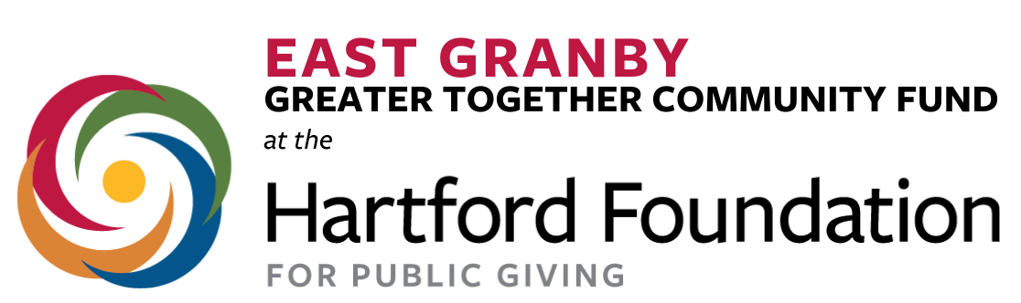

East Granby Greater Together Community Fund
Grant Application
Deadline: February 1, 2022
The East Granby Greater Together Community Fund is pleased to announce the availability of funding from the Hartford Foundation for Public Giving for projects directly benefiting the East Granby community. The purpose of East Granby’s Community Fund is to support residents in taking ownership around the needs in their towns and encourage broad and inclusive civic engagement. Further information about this group can be found by going to www.hfpg.org and then by clicking on the links to the Community Funds and our East Granby landing page.

Guidelines:
- The minimum amount of a grant request is $250. The maximum amount of a grant request is $25,000.
- Upon completion of the project, a final report may be requested. Information about follow up (photos, write up, invitation to grant event, etc.) will be shared after a grant is awarded.

Eligibility Criteria:
- The project/program proposed must directly benefit the residents of East Granby.
- Any nonprofit registered as a 501c3 organization, the town itself, or state/federal municipalities that serve the residents of East Granby are eligible to apply.
- Organizations must be classified as a 501c3 or have a fiscal sponsorship through a registered organization. Our town may serve as a fiscal sponsor to an organization who is not a registered 501c3. If you need help finding a fiscal sponsor, please contact the advisory committee at eastgranbygreatertogether@gmail.com.
- 509a3 charities and private foundations are not eligible.
- Grants need to be for future projects. Money cannot be requested to refund past projects.

Process:
- Applications should be completed as Google Docs, Word documents, or as a PDF.
- Please answer the following questions and submit a budget outline for this proposal.
- Please email completed applications to East Granby Greater Together at: Eastgranbygreatertogether@gmail.com. Applications can also be submitted via mail to: Jennifer Kovaleski,East Granby Greater Together, 73 Old County Road, East Granby, CT 06026.
1) Organization’s Contact Information:

Organization
or Community Group’s Name
Are you a registered 501c3? | Yes: What is your EIN?:  No:  If No, who will be your fiscal sponsor for this grant?  What is their EIN:
Total Funds Requested:
Contact Person’s Name and Title:
Address (include city, state, and zip code):
Contact Person’s Email:
Contact Person’s Telephone Number:
Group’s Website (if applicable):

2) Grant Request Project/Program Name:
Please provide a name for the project/program for which you are requesting funds. The name should not be more than a few words.

3) Organization’s mission:
Tell us about your organization or group.

4) Project/Program Description:
Briefly describe the project/program. What do you plan to do? Is this a new project or a
continuation? Please provide a timeline, if applicable. Are there other organizations in town that are associated with this?

5) Description of Need & Benefit:
Who will benefit from this program (number of people and description of population targeted for, geographic area to benefit - a specific neighborhood, entire town)? Why is the project you describe necessary? What is the expected benefit? How long will the benefit be felt?

6) Budget:
Please give a total dollar amount requested. Please give a detailed/itemized budget for the costs involved in this project/program. Referencing your organization’s/group’s annual budget may be helpful. Be as specific as possible.

7) The East Granby Greater Together Community Fund looks to reach broad and inclusive populations in our town.
Does your organization/group, or does this specific program/project, have focus to any of the following groups or populations (Check as many as applies.):

Seniors/The Elderly |  | Women
Persons with Disabilities |  | Immigrants
LGBTQIA+ |  | Non-Native English Speakers
Persons with Low or Limited  Economic Resources |  | Native American/Indigenous  Peoples
Black/African Americans |  | Hispanic/Latinx
Asian and/or Pacific Islanders |  | Youth/Students
Other, Please Share; |  | Other, Please Share;

8) Please share any additional information that you believe would be helpful to the advisory committee when reviewing this application.
Please address the following: Do you have other/additional funding resources? If you do not get full funding, will the project still be able to happen?

Please contact eastgranbygreatertogether@gmail.com with any questions or for a status update on your request.

