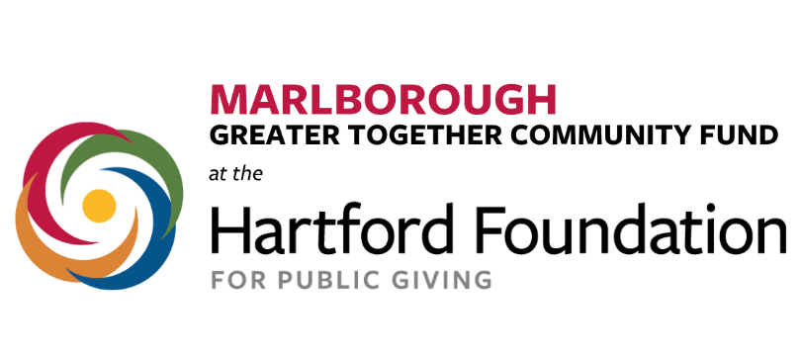

Parent/Legal Guardian Consent Form

PLEASE NOTE:
If you are under 18 years of age, you will need permission from a parent or legal guardian to apply to be considered for the Marlborough Greater Together Community Fund Advisory Committee. Please review with your parent or legal guardian and complete the following:

I, __________________________________________ give permission for
(name of parent or guardian)

____________________________________________ to apply to be a member
(name of applicant under age 18)
of the Marlborough Greater Together Community Fund Advisory Committee and if accepted, to participate in meetings and activities of the same. I understand the Community Fund Advisory Committee may wish to make known the success of this effort, and I authorize

____________________________________________ to appear in photos or videos for this purpose.
(name of applicant under age 18)

Parent/Guardian Signature: ________________________________________________
Date: _____________________________
Thank you for your interest.
Please complete and email this form to:
Communityfund.marlborough@gmail.com

